[TEAM OneTen]

**[Aromy Software]**

**Business System - ITERATION 1 Report**

**[VERSION FINAL]**



**PREPARED BY**

* Rui Qin 30874157
* Shangqian Du 31121632
* Pei Ern Cassandra Tong 31509509
* Eugene 27841898
* Daniel Phelan 29732638

[ 22nd August 2022 ]

# INTRODUCTION

This report intends to provide an overview of the first iteration and what will be delivered during the iteration. The overall goal of this project is to deliver a website for Aromy where the customers are able to purchase aromatherapy products and an advanced inventory management system on the administration side, to streamline the business processes and provide a baseline for future growth and expansion.

The main components of this report includes:

* An overview of the business requirements for iteration 1
* The personas of the users involved in this iteration
* A project timeline scheduled with the dates for team meetings and system review for this iteration
* Feedback Notes after the presentation

| CURRENT ITERATION OVERVIEW | | |
| --- | --- | --- |
| 1. |  | **Inventory(Products) Management System** |
| 1.1 |  | Reorder Stock List Report |
| 1.2 |  | View, Modify, Add, Delete SOH |
| 2. |  | **Order Management System** |
| 2.1 |  | View, Modify, Add, Delete orders |
| 3. |  | **Customer Management System** |
| 3.1 |  | View, Modify, Add and Delete customers |

# ITERATION TIMELINE

| FORMAL MEETINGS | DATE | ATTENDEES |
| --- | --- | --- |
| Iteration 1 Presentation | 22nd August, 2022 | Livia (Product Owner) & Team OneTen (All members) |
| Iteration 1 Build checkpoint | 29th August, 2022 | Team OneTen (All members) |
| Iteration handover for acceptance and integrity testing | 5th September, 2022 | Livia (Product Owner) & Team OneTen (All members) |
| Retrospective Artifacts Submitted | 8th September, 2022 | Livia (Product Owner) & Team OneTen (All members) |
| Post-Implementation Review | 10th September, 2022 | Livia (Product Owner) & Team OneTen (All members) |

# 

# 

# 

# 

# PERSONAS

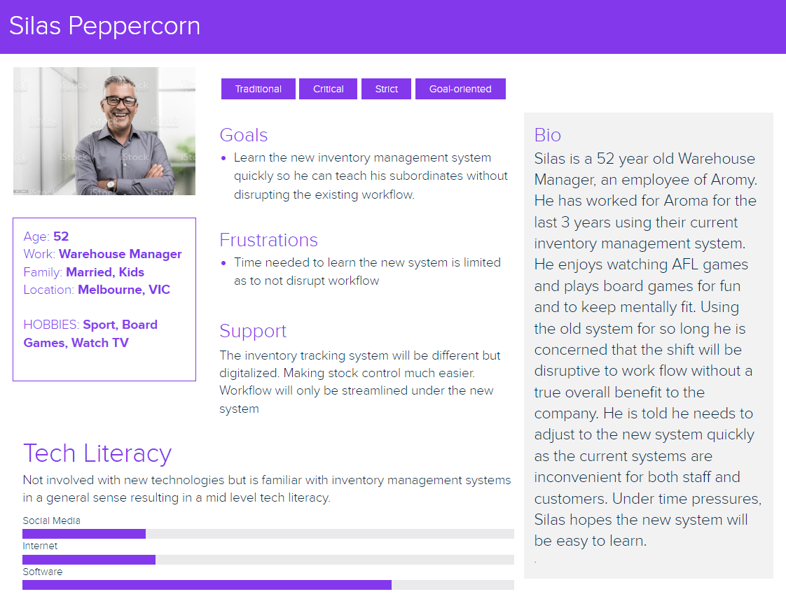

# 

# 

# 

# 

# 

# CLIENT FEEDBACK

1. Livia would like to include a customer persona in this iteration so we can understand the project requirements for a customer. The team will look at adding a customer persona for a future iteration, as this first iteration is more focused on administrators.
2. PIR should have the team and product owner rather than just the product owner.

# SUMMARY

Please contact the team or the client liaison with any questions or concerns you may have after seeing the showcase of your product. We are delighted to adjust or fulfill your business needs. We are looking forward to our next meeting to understand more about your business requirements.

Cassandra Tong,

Client Liaison

[pton0008@student.monash.edu](mailto:pton0008@student.monash.edu)

On behalf of team OneTen.